Fish Passage Operation and Maintenance (FPOM) Team meeting Agenda

13 May 2021 0900-1200

Conference Call

**Conference line:** **1-844-800-2712** **Access: 199 076 9084**

**Webex meeting:** <https://usace1.webex.com/usace1/j.php?MTID=mfd2225aec54960151ed1beffdc99906a>

**Access Code: 199 076 9084 Password: fy21FPOM\*\***

Documents may be found at: <http://pweb.crohms.org/tmt/documents/FPOM/2010/>

1. **Approve April Meeting Minutes**

1. **Action Items**
   1. **NWW**
      1. **[March 21]** McNary steelhead overshoot study – waiting on results. ACTION: Peery will share.
      2. **[March 21]** 21 LGS 01 MOC Unit Priority Change to Facilitate Debris Removal.ACTION: Peery will report back to FPOM next month about path to re-design of debris boom.
   2. **NWP**
      1. **[February 21]** CI PIT tag antennae electrical work. **ACTION:** Hausmann will let Warf know when that work will be completed so PITAGIS can be on-site to assist as needed. All above water work now. Waiting on funding to finish this job. Warf asked if there was any idea when funding will come through? *Hausmann will check today with funding folks. UFR’s will be worked in May, new update then.*
      2. **[August 20] TDA Turbine Dewater Sturgeon SOP (6’ and greater) -** ACTION:

We will have a more detailed discussion once SOPs from the Project Bios for removal and/or leave fish in place are developed. *Update: Cordie provided PowerPoint showing cross section of turbine relative to tailwater levels and posted it to the FPOM website. Van Dyke will look at .ppt and get back to Cordie with any questions.*

* + 1. **[2019] TDA East Exit boundary**. Morrill will visit after 2nd COVID-19 vaccine and decide where boundary line should be. This area is in Washington’s waters and out of OSP’s authority.

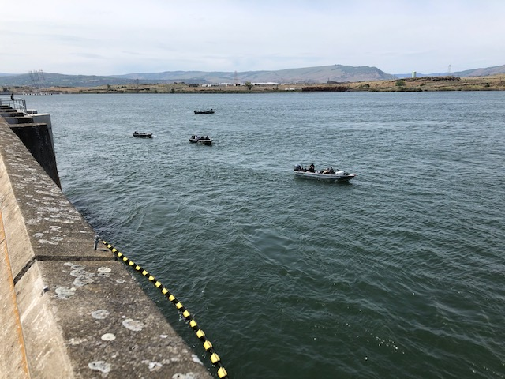Figure 1. From Bob Cordie, “. . .here is a pic of boats trolling by our east fish ladder exit. ~50’ from exit in this pic. Caught them this AM about 15’ away. Watched 3 springers landed in ~10minutes. Good take considering we passed 50 springers that hour. More efficient than see lions. Please post this to FPOM site for all to see as well.”

* 1. **Completed Action Items or to be discussed later in the agenda**
     1. [March 21] Little Goose count station modifications to reduce entrained air. ACTION: Peery will take to FFDRWG.
     2. [March 21] McNary juvenile fish facility late start. ACTION: Griffith will take request for early start in 2022 back to Project, Bobby Johnson (MCN). Project is anticipating early start next year. Corps working early start 2022 internally

1. **Updates**
   1. **NWW**
      1. Upcoming maintenance/construction/research activities.
         1. McNary spillway crane repairs
      2. **20 MCN 17 MOC T1 Oil Leak Repair**. Still pending. Waiting to hear if gasket repair can occur at the same time as the Doble testing and BPA work. Work to occur in August.
      3. Little Goose transformer replacement.
      4. Ice Harbor trash rake replacement/repair
      5. Invasive species discussion.
         1. Juvenile shad removal from samples (Peery)

* 1. **NWP**
     1. Invasive piscivorous fish control opportunities (Cordie)
     2. Upcoming maintenance/construction/research activities.
        1. 21 BON 001 MOC Navigation Lock 1 (old navlock) Bridge Replacement (Trachtenbarg)scheduled for CY2023**.**
        2. 15TDA08 MOC Transformer Installation.
        3. 19TDA04 MOC Crane rail Replacement winter (20/21)
        4. 20TDA10 MOC PUD Smolt Bypass Extended Outage
        5. 18JDA02 MOC Trash rack replacement.
        6. 20JDA04 MOC STS crane replacement.
     3. BON Cascade Island PIT tag antenna completion.
     4. BON Aqui-S update.
     5. BON ITS Gate
     6. BON PH2 gantry crane replacement
     7. TDA AWS debris management. (Rerecich FC, Medhi Rashani TL, Kovalchuck temp PM)
     8. TDA trunnion pin. Via email from Michael S Colesar, on 1/28/2021 “Gate 9 trunnion would be part of a larger project to completely rehab Gates 1-9. SAP shows Start in 2031, Construction 2034”
     9. JDA north pumps.
     10. JDA spill bay 10. In manual operation, have not figured out remote operations from the control room, likely manual most of spill season
     11. JDA elevator #4
  2. **NWS (Seattle)**.
  3. **Research/FFDRWG updates.** <http://pweb.crohms.org/tmt/documents/FPOM/2010/FFDRWG/FFDRWG.html>
     1. **NWP FFDRWG.** Next meeting May 6th
     2. **NWW FFDRWG.**
  4. **RCC update**

|  |  |  |  |  |
| --- | --- | --- | --- | --- |
| **Project** | **Previous Day Average Outflow (kcfs)** | **5 Day Forecasted Inflow (kcfs)** | **10 Day Forecasted Inflow (kcfs)** | **Forecasted Inflow Low/High (kcfs)** |
| **LWG** |  |  |  |  |
| **MCN** |  |  |  |  |
| **BON** |  |  |  |  |

**Table 1. NOAA Northwest River Forecast Center inflow forecast.**

* 1. **BPA update.**
  2. **Fish Count Program update (Peery, Wertheimer).**
  3. **Pinniped update** 
     1. **Bonneville Dam**
     2. **Willamette Falls**
  4. **Lamprey update**
  5. **Avian updates (10:30)**
     1. **NWW**
     2. **JDA**
     3. **TDA**
     4. **BON**
     5. **Estuary**

1. **Coordination/Notification forms (need concurrence/discussion)**
   1. 21 BON 007 MFR AFF Steelehead Morts
   2. 21 TDA 05 MFR East ladder fish unit outage
   3. 21 JDA 04 MFR South Fish Ladder Out of Service for Debris Removal
   4. 21 MCN 04 MFR Gate in Bay 6 Found in Split Leaf
   5. 21 LWG 06 MOC AWS PUMP #1 RTS
   6. 21 LWG 07 MFR RSW Log Removal
2. **Fish Passage Plan:** The 2021 FPP went into effect March 1 and is available online at: <http://pweb.crohms.org/tmt/documents/fpp/2021/>
   1. **New Change Forms:** 
      1. **21AppB001 – LMN Condition Sampling (Conder)**
      2. **21TDA002 – Unit 8-2 Sluicegate (Cordie)**
3. **Task Group Updates.**
   1. Avian Task Group meeting (Cordie)
      1. <http://pweb.crohms.org/tmt/documents/FPOM/2010/Task%20Groups/Task%20Group%20Avian%20Hazing/>
   2. Task Group Condition Monitoring (Lorz & Sullivan)
      1. <http://pweb.crohms.org/tmt/documents/FPOM/2010/Task%20Groups/Task%20Group%20Condition%20Monitoring/>
         1. Condor requested a LMN condition monitoring meeting, scheduled for 4/15.
   3. Task Group 15 Mile Steelhead Overshoots, TDA ITS operation dates. (Bellerud)
      1. <http://pweb.crohms.org/tmt/documents/FPOM/2010/Task%20Groups/Task%20Group%20TDA%20ITS%20operations/>